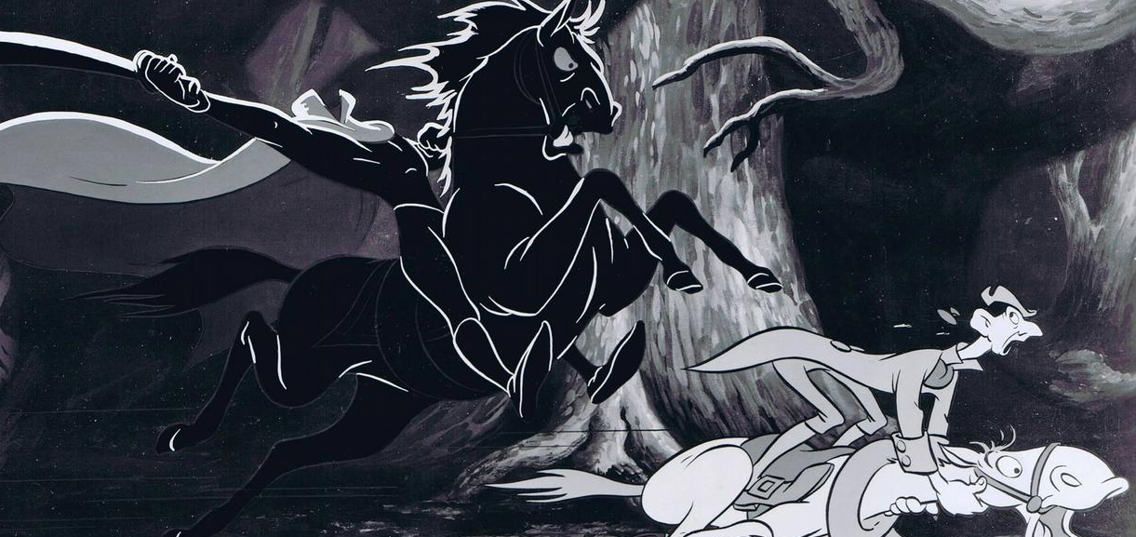
Name _____________________________________ Date ________________________

Write a Brief summary of The Legend of Sleepy Hollow.

________________________________________________________________________

________________________________________________________________________

________________________________________________________________________

________________________________________________________________________

________________________________________________________________________

________________________________________________________________________

________________________________________________________________________

________________________________________________________________________

________________________________________________________________________

________________________________________________________________________

________________________________________________________________________

________________________________________________________________________

________________________________________________________________________

________________________________________________________________________

________________________________________________________________________

________________________________________________________________________

________________________________________________________________________

________________________________________________________________________

